Ideation Phase
Brainstorm & Idea Prioritization Template

Date | 19 November 2022
Team ID | PNT2022TMID49214
Project Name | Smart Solutions For Railways
Maximum Marks | 4 Marks

Brainstorm & Idea Prioritization Template:

Brainstorming provides a free and open environment that encourages everyone within a team to participate in the creative thinking process that leads to problem solving. Prioritizing volume over value, out-of-the-box ideas are welcome and built upon, and all participants are encouraged to collaborate, helping each other develop a rich amount of creative solutions.

Use this template in your own brainstorming sessions so your team can unleash their imagination and start shaping concepts even if you're not sitting in the same room.

Reference: https://www.mural.co/templates/empathy-map-canvas

Step-1: Team Gathering, Collaboration and Select the Problem Statement

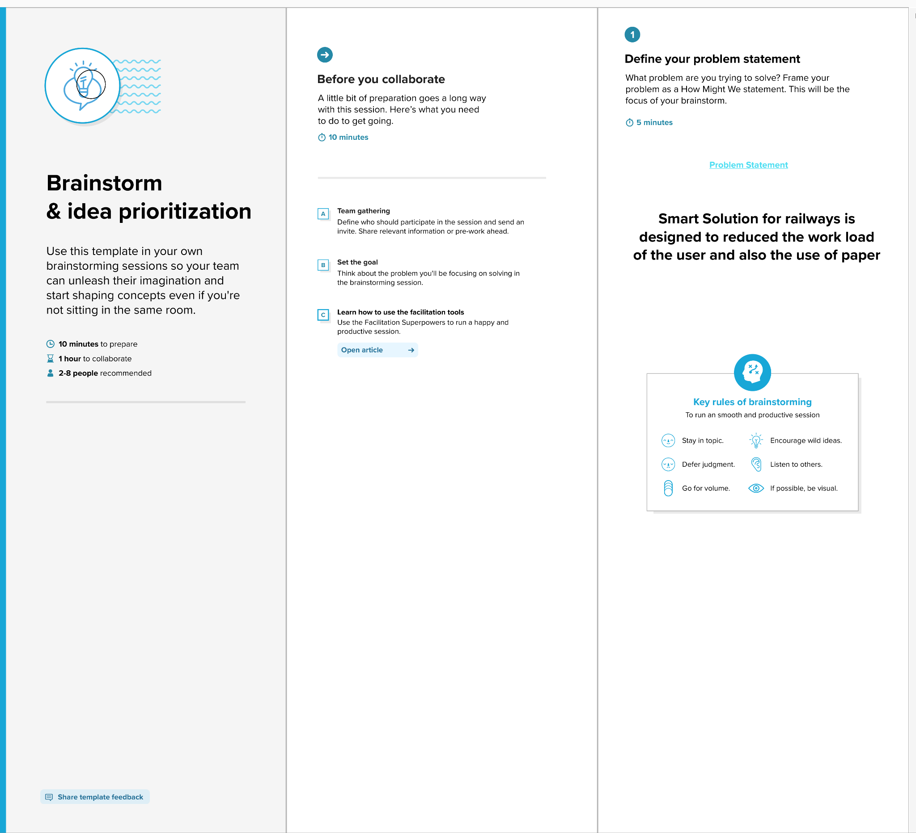
Step-2: Brainstorm, Idea Listing and Grouping

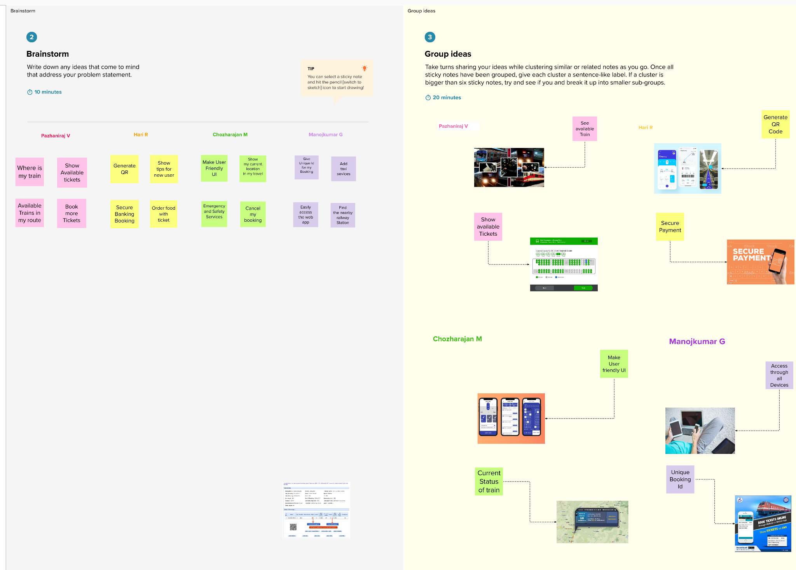

Step-3: Idea Prioritization
